DIAGNOSTICS AND TREATMENT OF TEMPOROMANDIBULAR JOINT DYSFUNCTION AND MASTICATORY MUSCLES PARAFUNCTION IN NAVAL FLEET PERSONNEL
Anton A. Serikov, Andrey K. Iordanishvili, Vadim V. Voskresensky
S. M. Kirov Military Medical Academy, St. Petersburg, Russia

Functional pathology of the masticatory apparatus in the form of dysfunction of the temporomandibular joint and parafunctions of the masticatory muscles is common, which is caused by early loss of natural teeth in young and middle-aged people. In adults in common the prevalence of this type of violation prevails in 12-75% of the cases, but in the people with occupational hazards the figures can increase to 95-100%. Despite the fact that the study of the dental status of the military personnel of the Navy was carried out repeatedly, only a few studies paid attention to identifying the temporomandibular joint and masticatory muscles functional pathology and, as a rule, it was studied in a small sample of subjects. The possibilities for diagnosing and treating such diseases on ships of the Navy are very limited because of the lack of dental equipment and the inaccessibility of an X-ray examination. It should be noted that reporting on dental morbidity in the system of the Ministry of Defense of the country also does not take into account this pathology. However, it is known that there are certain difficulties in the treatment of patients suffering from the temporomandibular joint dysfunction and the masticatory muscles parafunction, which often recur, and long-term arthralgia or myalgia can adversely affect the performance of military duties, especially in a long-distance voyage.
Key words: maritime medicine, therapeutic dentistry, dysfunction, temporomandibular joint, functional pathology, masticatory muscles parafunction.

For references: A.A. Serikov, A.K. Iordanishvili, V.V. Voskresensky. Diagnostics and treatment of temporomandibular joint dysfunction and masticatiry muscles parafunction in naval fleet personnel // Morskaya Meditsyna. Marine Medicine (maritime medicine). 2019. No. 1. S. 00–00, DOI: https://doi.org/10.22328/2413-5747-2018-5-1-35-38

Introduction The masticatory apparatus pathology being considered in the form of diseases of the temporomandibular joint disorder (TMJ disorder) and masticatory muscle parafunction is often found in a naval ship’s company and, despite the absence of active complaints from the subjects, occurs in most cases in a moderate form [1, p. 14-25]. Identification of this type of pathology and its timely treatment will contribute to the preservation and strengthening of dental health, professional longevity, as well as increasing the ability to perform combat and other tasks by the naval craftsmen [2, p. 4-11; 3, c. 255–261].
Objective: to study the degree of incidence, the possibility of diagnosing and treating the temporomandibular joint dysfunction in a naval ship’s company.
Materials and methods. A clinical examination in 172 military personnel (men aged 21 to 52 years) at the naval ship’s company was conducted. For comparison, 502 military personnel (men aged 21 to 52 years) from the coastal units were examined. The survey in the naval personnel of the company was carried out aboard the ship under the long-distance navigation conditions. Four military personnel once performed intra-articular administration of the hyaluronic acid preparation, followed by dynamic monitoring for 6 months and assessing the effectiveness of the treatment.
The functional pathology of the masticatory apparatus was revealed during a dental examination, for which people were purposefully questioned and identified the main clinical signs characteristic of the TMJ pathology and masticatory muscles pathology. To establish the TMJ pathology, the nature of the opening of the mouth, the deviation of the lower jaw during opening and closing the mouth were evaluated, sound phenomena in the TMJ were revealed (crepitating, crunching, clicking) [4, p. 141-153]. In addition, the presence of joint pain was assessed in the state of physiological rest of the lower jaw, as well as with movements of the lower jaw. The servicemen were interviewed for their complaints of the masticatory muscles of fatigue during a conversation or inappropriate movements of the lower jaw, as well as “grinding” of teeth. Hypertrophy of the masticatory muscles was being detected (single or bilateral), as well as pain during the masticatory muscles palpation. The presence of indirect signs of masticatory muscle parafunction was determined in parallel, namely, chronic inflammatory periodontal diseases (periodontitis) and increased abrasion of hard tooth tissues. Using myotonometry, indicators of the tone of “rest” and “compression” of the masticatory muscles on both sides were evaluated and compared with age-related physiological values [5, p. 31–37; 6, c. 11-14].
After registration of the revealed pathological symptoms indicating the presence of a functional pathology of the dental-maxillary apparatus, the severity of the TMJ pathology and masticatory muscle parafunctions was determined according to the generally accepted method [7, p. 15-17]. It should be noted that auscultation and myotonometry data were necessary to assess the severity of the TMJ pathology and the masticatory muscle parafunctions.
The digital material obtained as a result of a clinical study was processed by a PC using the “Statistica for Windows v. 6.0” specialized package for statistical analysis. The differences between the compared groups were considered significant at p≤0.05.
Results and their discussion. It should be noted that complaints from the examined individuals in the control and main groups of the existing TMJ and masticatory muscles pathologies were not independently presented [8, p. 4-13]. At the same time, a purposeful history taking made it possible to clarify the presence of clinical manifestations of functional pathology of the masticatory apparatus in them, which influenced the determination of the severity of TMJ disorders and masticatory muscles parafunctions.
During a clinical examination of the military personnel’s control group it was found that clinical signs of TMJ pathology were detected in 12.75% of cases (64 people), and masticatory parafunction in 2.39% (12 people) of cases. Analysis of pathological symptoms from the TMJ made it possible to clarify the severity of the course of its pathology (Fig. 1). A mild degree of TMJ pathology was found in 39 people (60.94%); medium – in 21 (32.81%), severe – in 4 military men (6.25%).
A mild degree of masticatory muscle parafunction (Fig. 2) was detected in 8 people (66.67%); the average was in 3 people (25%), and the severe degree was in one military man (8.33%).

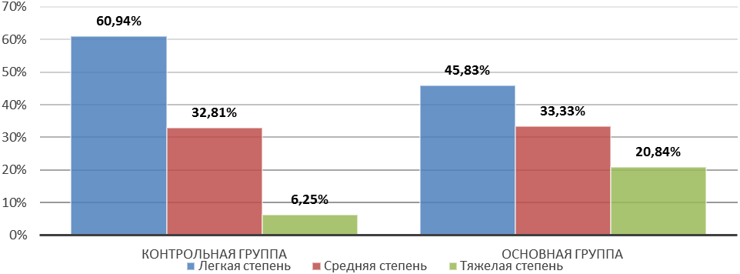
Figure 1. TMJ dysfunction severity assessment, %

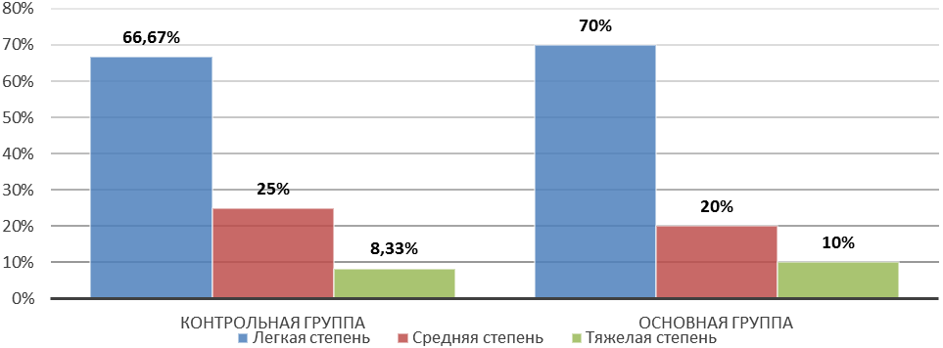
Figure 2. Masticatory muscles parafunction severity assessment, %

When conducting a clinical examination of military personnel on a ship in a long-distance voyage, the masticatory apparatus pathology was detected often and significantly more often proceeded more severely (p≤0.05). Compared with the control group, the frequency of TMJ pathology was 27.9% (p≤0.05), and masticatory muscle parafunctions were diagnosed in 11.62% of cases (p≤0.05), i.e., 48 and 20 naval personnel respectively. More often this pathology in the ship’s company was an easy one. A mild degree of TMJ dysfunction was detected in 45.83% of cases (22 people), masticatory parafunction – in 70% of cases (14 people). An average degree of TMJ dysfunction and masticatory muscle parafunction was detected in 33.33% and 20% of cases, respectively. A severe form of TMJ dysfunction and masticatory muscle parafunction were affected by 20.84% and 10% of the naval personnel surveyed, respectively.
During the voyage, it was possible to test the method for treating TMJ dysfunction for use on ships of the Navy by intra-articular injection of a viscoelastic synovial fluid implant based on hyaluronic acid (see the photo below). TMJ puncture was performed by 4 military men, while 2 of them had moderate TMJ dysfunction, and 2 the other 2 men had a severe degree. After 6 months, a control examination was conducted to assess the severity of the TMJ dysfunction. It was revealed that in one person who previously suffered from moderate severity of TMJ dysfunction, a complete regression of symptoms was observed. In 3 servicemen, the severity of TMJ dysfunction decreased to mild. Due to the limited amount of drug to be administered, no statistical calculation was made.

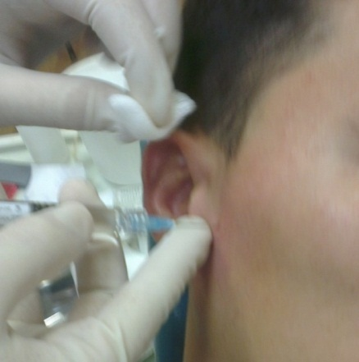
Photo
The procedure of intra-articular injection of hyaluronic acid in the conditions of the shop’s medical center

Conclusion. The combined pathology of TMJ and masticatory muscle parafunctions observed in 52.8% of the examined individuals indicates identical causes and similar mechanisms of progression of this pathology, which is primarily associated with occupational hazards (vibration, noise, psycho-emotional stress, etc.). The information obtained on the frequency of occurrence of functional pathology of the masticatory apparatus in the ship’s company is of practical importance, since the prevention of their occurrence and treatment should include not only occlusal rehabilitation during the medical examination, but also the involvement of a medical psychologist or a psychotherapist. However, at present, the possibility of a medical service for the diagnosis and treatment of this pathology on ships of the Navy, even if there is a dentist surgeon specialist, is sharply limited due to the lack of equipment with X-ray aids, consumables, and the impossibility of manufacturing therapeutic mouthguards. These circumstances indicate the need to find alternative diagnostic and treatment options for TMJ disorders in a ship’s company with the aim of reducing the dental morbidity on the ships of the Navy.

References
1. A.K. Iordanishvili, L.N. Soldatova, G.A. Ryzhak. Diagnosis and treatment of diseases of the temporomandibular joint and masticatory muscles in the elderly. St. Petersburg: Nordmedizdat, 2011. 134 pages (in Russ.)
2. A.K. Iordanishvili, N.A. Udaltsova, V.V. Samsonov A.A. Serikov, G.A. Ryzhak. Diagnosis and treatment of diseases of the temporomandibular joint in outpatient facilities. St. Petersburg: Nordmedizdat, 2012.132 pages (in Russ.)
3. A.K. Iordanishvili. Diseases, injuries and tumors of the maxillofacial region. St. Petersburg: SpetsLit, 2007. pp. 255–294 (in Russ.)
4. A.K. Iordanishvili. Clinical orthopedic dentistry. M .: MedPress, 2008.208 pages (in Russ.)
5. A.K. Iordanishvili, K.A. Ovchinnikov, L.N. Soldatova., A.A. Serikov, V.V. Samsonov. Optimization of diagnosis and evaluation of the effectiveness of treatment of diseases of the temporomandibular joint and masticatory muscles in dental practice // Bulletin of the North-West State Medical University. 2015.V. 7, No. 4. pp. 31–37 (in Russ.)
6. A.A. Serikov. Anatomical prerequisites for the occurrence of dysfunction of the temporomandibular joint in various age periods in an adult. SPb .: SPbSPMU. 2013.20 pages (in Russ.)
7. A.K. Iordanishvili, N.A. Udaltsova, L.N. Soldatov, A.A. Serikov, V.V. Samsonov, G.A. Ryzhak. Prediction, assessment of the severity and effectiveness of treatment of diseases of the temporomandibular joint. SPb: SPbIBiG - SZO RAMS - Nordmedizdat, 2012. 30 pages (in Russ.)
8. A.S. Ivanov. Arthritis and arthrosis of the temporomandibular joint. L .: LSGMI, 1984. 32 pages (in Russ.)

Received by the Editor: 01.01.2019
Contact: Anton A. Serikov, e-mail: mdgrey@bk.ru, tel.: + 79818978358

Author’s credentials:
Anton A. Serikov – lieutenant colonel of the medical service, candidate of medical sciences, senior lecturer of the department of therapeutic dentistry of the S. M. Kirov Military Medical Academy named after; 194044, St. Petersburg, Lebedeva st., 6; e-mail: mdgrey@bk.ru;
Andrey K. Iordanishvili – colonel of the medical service, Doctor of Medical Sciences, Honored Innovator of the Russian Federation, Professor of the Department of Maxillofacial Surgery and Surgical Dentistry of the S. M. Kirov Military Medical Academy; 194044, St. Petersburg, Lebedeva st. 6;
Vadim V. Voskresensнk – 4-year cadet of the faculty of training doctors for the Navy of the S. M. Kirov Military Medical Academy; 194044, St. Petersburg, Lebedeva st., 6; e-mail: konzepziakob@mail.ru.

